Curriculum Vitae
The Altair
905/3 Kings Cross Road
Rushcutters Bay NSW 2011
GPO Box 3741
Sydney NSW 2001
Tel: 0405-994774
Fax: 02-9475-0047
E-mail: simv@pobox.com

..........
.
.
.
.
.
..
.
.
.

.
.
.
.
.
.
.
.
.

Simon
Verdon

Chartered Accountant with CEO and CFO expertise
Founder and CEO of U.S. e-commerce business for the past 11 years
Founder and CEO of Australian/Asian video training business
Initial CFO (through to IPO) of division of major media conglomerate
Identifying and securing products and media rights
Selection, management & training of international and Australian staff
Reporting to board, investors, and lenders
Extensive experience in Australia, U.K., U.S.A, & Hong Kong
Long-term commitment to all business positions

Simon Verdon
Curriculum Vitae
.
.
.
.
.
.
..
.
.

Binder Hamlyn, London To 1972
I qualified as a Chartered Accountant with this London firm which was at the time one of the ten largest firms in England. Although principally involved in audit, I completed a large number of special projects which developed my analytical and reporting skills. In the four years after qualifying, I progressed through four supervisory levels to become at 25 the youngest Audit Manager ever appointed in the firm. I had responsibility for the largest audit clients and this brought me into social contact and negotiation with directors of public companies.
When I let it be known that I wanted to travel, the firm paid for me to visit its associates in Hong Kong and Melbourne, but in the end the need for change took me to an Audit Manager’s position with Peat Marwick in Hong Kong.
Communicating effectively at senior management level
Managing a large staff in disparate, simultaneous projects
Extensive media industry experience
Peat Marwick, Hong Kong 1980
This was not a smart move. Peat Marwick, largely because of the way business was done in Hong Kong, was a very staid and rigid work environment which I did not enjoy at all. Hong Kong and its business ethic was totally unlike that which I had experienced in England. It encouraged me to think entrepreneurially and internationally.
After discussions with Australian and UK managing partners when they visited Hong Kong, I accepted an offer to work in the Sydney partnership of Binder Hamlyn, with the prospects of an early partnership.
Exposure to extremely entrepreneurial corporations
Asian business practice and staff management
Binder Hamlyn, Australia To 1982
I became involved with the audit of the Consolidated Press group at an early stage, but this quickly developed into a number of special financial projects for the Packer group including ski resort profitability analysis and special interest magazine publishing.
I agreed to transfer to Melbourne as a partner-elect at age 30. But at the point when I was considering whether I could work with my prospective partners, one of Kerry Packer’s senior executives came to Melbourne to ask if I wanted to be involved in the financial control of an absolutely new technology – home video.
Project analysis in the communications & publishing industry

Simon Verdon
Curriculum Vitae
.
.
.
.
.
.
..
.
.

Publishing and Broadcasting Video To 1985
It seems strange to relate now, but a move from the accounting profession to a business accounting position was, at the time, an irreversible commitment. It is a move which turned out to be one of the best of my working career.
Home video was in its infancy and many theories on how it could be turned to profit were being discussed. I was Vice President, Finance of a division of Channel 9 which had committed nearly $10million to product rights when I joined. As one of 5 Vice Presidents, the environment was exciting and incredibly fast-moving. We went from zero to approximately $40million a year in sales in about three years. It was my job to create a financial and organisational structure for this growth. I also needed to liaise with the divisional Vice Presidents and the holding group to ensure they had the decision-making information and planning assistance they required.
We established operating subsidiaries in Asia with systems to manage the many and complex video licensing agreements which had been concluded with US and European movie studios.
The group engaged in many new ventures and acquisitions. In all cases, I was involved in the ‘due diligence’ process which honed my skills in assessing business opportunities, and in successfully integrating very differing businesses into our growing group. At the same time, I acquired responsibility for the sale of Taurina Spa mineral water and learned about some of the aspects of mainstream retailing.
Like most senior financial executives, I had a desire to run an entire operation. I became General Manager of Video Channel, a relatively small division which distributed training videos to businesses.
During this period, the entire group was the subject of an IPO and was successfully listed on the ASX. As a continuing member of the senior management, I was involved in the production of the prospectus and was awarded options in the new venture.
Over the next 18 months we grew Video Channel by 100% but it remained a poor relation of the more exciting home video divisions. As we did not represent a core business to the new corporation, I made an offer with my Sales Manager to acquire the division but failed to reach agreement with the new holding company.
Key Experience:
Meeting the needs of corporate management
Liaising with holding company executives
Managing a diverse range of staff in a large group
Assessing new business opportunities and merging with existing divisions
Doubling an existing, mature business

Simon Verdon
Curriculum Vitae
.
.
.
.
.
.
..
.
.

First Training To 1993
In January 1985, we therefore founded our own training video distribution company in Australia with an external investment of A$250,000. This company was later to become First Training, the largest distributor of training videos in the Southern Hemisphere. By 1993, when I sold my shareholding, First Training had grown from startup to a business with A$8 million in annual sales from 9 offices in 4 countries, employing 50 staff.
During this entire period I was Joint Managing Director and a major driving force in the expansion of the business and the introduction of necessarily increasingly complex reporting and control systems. These were at the same time the most exciting, frustrating, satisfying, and exhausting 8 years of my life.
The best times for me were the middle years when we had passed the problems of a startup, had a great, loyal, and highly committed team, and could see a real vision for the future. We felt we had something very special going for us. During this period, I worked very closely with my founding partner who managed the sales force, and we learned how to execute and develop ideas jointly.
We started with a few distribution licenses from producers we had not represented at Video Channel, and at the end we had all the licenses and no practical competitors. Gaining those licenses from international distributors required tenacity and inventiveness, which was both challenging and rewarding. I learned a great deal during this period about negotiation and marketing what we had to offer as a distributor in an international context.
We grew partly through the acquisition of licenses, but also from internal sales expansion and never allowing a marketing opportunity to pass by. As our competitors weakened, we acquired or merged with them. But in getting to this point, we had, of necessity, involved too many non-managerial shareholders. We had also been too kind in assessing the capabilities of staff we acquired in two major takeovers/mergers. In particular, the last of these left us with a highly politicised management structure.
My founding partner in the business had by this time retired to Queensland and I felt I needed to leave the politics behind and start a new self-funded venture in which I would be the sole shareholder. So in late 1993, I resigned and sold my shareholding in First Training.
Key Experience:
Being responsible for all aspects of a new business
Negotiating with shareholders and lenders
Being a CEO but developing ideas in cooperation with others
Using new technology to improve company performance
Creating a large company from zero

Simon Verdon
Curriculum Vitae
.
.
.
.
.
. .
.
.
.
.
.
..
.
.
.
.
.
.
.
.
..
.
.
..
.
.

Catch 123 1983 to 1985
The origins of Open Communications Inc lie with its Australian parent, Open Media Pty Limited. That company was formed in March 1984, as Catch 123 Pty Limited, to exploit portable computers in the context of film production. To that point, all movie production accounting was a hopelessly historic affair. Films costing multi-millions would be all but finished before accurate cost analyses were available. Open Media used portable PC’s to provide up-to-the-minute financial information during the course of film production. I became adept at amending computer software, using a variety of programs to meet the needs of production companies in controlling and monitoring finances.
We sold the film production accounting business to one of our staff after about 3 years.
Key Experience:
Adapting proprietary software to produce a specialised solution
Self-taught understanding of the detail of many computer programs
Awareness of the film finance and production process

Open Media To 2005
In the early 90’s, we leveraged our knowledge of the film-making process and my involvement in training film distribution, to produce a series of Australian training videos using well-known local actors. Open Media licenses the videos for distribution, principally in Australia but also worldwide. The six videos we produced have generated some A$1.5million in gross sales in the last 14 years.
In early 2005, I partnered with a former employee to create a new Australian e-commerce site (www.CocoLily.com.au) using the experience gained in Open Communications (see below). We are concentrating on sourcing interesting and hard to find items, and those where overseas wholesale prices allow us to offer significant discounts on normal Australian online prices. It has also proved a valuable learning experience in putting in place the latest e-commerce tools now available.
This project has encouraged me to look further at using OpenMedia.com.au to offer additional directory services to the Australian market.
Key Experience:
Locating and licensing worldwide distributors
Locating and securing US wholesale supplies
New e-commerce tools and techniques
.
.
.
.
.
.
..
.
.

Simon Verdon
Curriculum Vitae
Open Communications To 2005
In 1994, I decided to move to the USA as I had long been impressed by the entrepreneurial character of American business. In addition, it was clear that, at the time, any internet business would need to be based in America. I set up a US subsidiary, Open Communications Inc, in Phoenix, Arizona.
In September 1995, Open Communications established a presence on the Internet at www.OpenGroup.com. Since then, our subsidiary web sites and branding have been developed to sell to the US market through NetStoreUSA.com, to the world through WorldRetailStore.com, and to Australia through NetStore.com.au.
After the boom and bust of internet e-commerce ventures, very few remain who rely solely upon internet e-commerce (‘pure play’ websites), being neither bricks and mortar based nor part of a larger business conglomerate. They can be divided into giant ‘category killers’ who have spent billions in shareholder funds to create a presence, and small ‘niche marketers’ such as us. We have bootstrapped and survived totally with internal finance, through astute product selection, rigorous cost control, and highly-targeted marketing.
Although our product range numbers some 3 million items, we concentrate on non-fiction UK and Australian books, Spanish and German books, world maps, sheet music, and music supplies. We have in particular sought out product lines capable of very precise description, such as specific brands of guitar string, maps of defined localities, or special books like ‘A Zoroastrian Tapestry: Art, Religion & Culture’. We can then set about having the items listed on search engines without having to compete for position with hundreds of other generic descriptions.
We have less than ten major suppliers, many of whom ship direct to our customers. We do not carry any items in stock but order from suppliers only to fill customer orders we receive. In consequence, our offices in Phoenix are very modest and our staff concentrate on order processing and customer service.
Our sites, presenting some 3 million products, have been devised and built by me in cooperation with our part-time web developer. We were one of the first sites on the internet to offer secure online order processing. We deliver worldwide but have learned how to minimize fraud to the point where this has reached almost zero. All of this control, born of my experience as an auditor, is necessary as the margins available from internet product sales can be extremely fine. In the process of creating and managing our websites, we have developed valuable contacts in site design, content, marketing, and back-end operations.
We have been under-capitalised from the outset and were not part of the dot.com boom in the USA as at that time I did not have residence status. We have therefore been unable to invest in marketing to build a brand. We have instead taken every opportunity to obtain listings in search engines, almost all of them free.
As a result, our sites receive some 20,000 unique visitors every day. The following chart is some measure of our success. It assesses the cross links to our pages from third party sites and compares the total linking to us with others in the media sector. Based on these statistics, two of our sites are classed as a ‘Players’ and the largest as a ‘900 pound gorilla’. Taken together, our third party links are 24 times those of www.Seek.com.au.
After 11 enjoyable years in the USA, I have decided for personal reasons to return to Australia. This, and my reluctance to involve third-party investors in the US business means that the options to further expand Open Communications are limited. The company continues to operate in my absence without my day to day involvement.
Key Experience:
11 years of e-commerce in the US and world market
Understanding product requirements for successful e-commerce
Negotiating product rights from those suspicious of the internet
Website design and page design to maximize exposure
Analysis of allowable promotion margin on marketing projects
Knowledge of tools to secure search engine placement
Application of cost control at product and overhead levels
Avoidance of credit card fraud
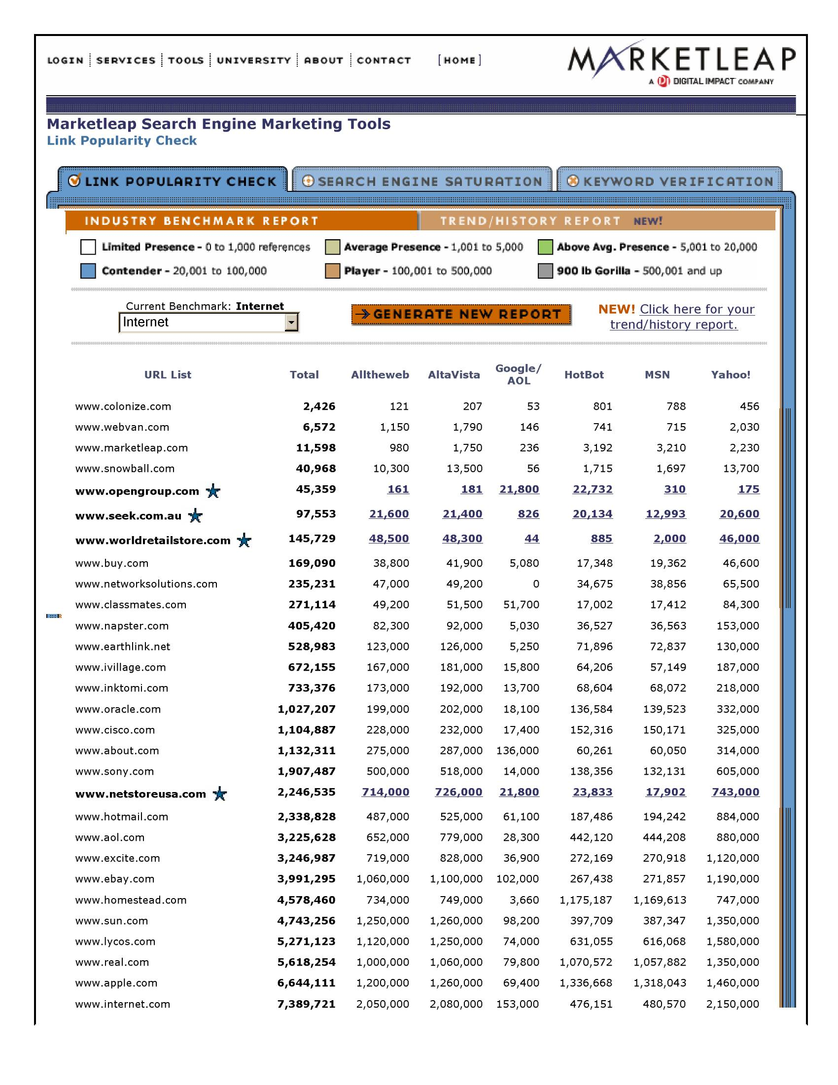

Simon Verdon
Curriculum Vitae
.
.
.
.
.
.
..
.
.

Personal Information
Date of birth |  | 16th August 1951
Place of birth |  | London
Nationalities |  | Australian & British  US resident status (Green Card)
Health |  | Good
Marital Status |  | Divorced; no children
Education
University of Kent, Canterbury | BA with Honours in Accounting |  | 1969 to1972
Merchant Taylors’ School | 8 Ordinary Levels; 3 A Levels |  | 1962 to 1969
Qualifications
Fellow of the Institute of Chartered Accountants in England & Wales |  |  | 1975
Employment
Open Communications Inc | Owner and President |  | 1994 to 2005
First Training Pty Limited | Joint Managing Director |  | 1986 to 1993  Salary: A$35,000->A$110,000
Open Media Pty Limited | Owner; Producer; Distributor |  | 1985 to 2003
Video Channel Pty Limited and  Publishing & Broadcasting Video | General Manager  Vice President - Finance |  | 1984 to 1985  1982 to 1984  Salary: A$30,000->A$75,000
Catch 123 Pty Limited | Owner |  | 1983 to 1985
Binder Hamlyn, Australia | Manager; Partner designate |  | 1981 to 1982
Peat Marwick, Hong Kong | Audit Manager |  | 1980
Binder Hamlyn, London | To Audit Manager |  | 1972 to 1979
Companies above owned by Verdon are italicised.
Open Communications Inc | Open Media Pty Limited
10640 N 28th Drive | GPO Box 3741
Suite A200 | GPO Sydney
Phoenix AZ 85029, USA | NSW 2001, Australia
1-800 GET OPEN | Phone: 02-9475-0047
1-800 FAX OPEN | Fax: 02-9475-0047
+1-602-532-7038
www.netstoreusa.com; www.opengroup.com; www.worldretailstore.com | www.openmedia.com.au;  www.netstore.com.au  www.cocolily.com.au
simv@pobox.com | Home: 02-9380-2848  Mobile: 0405-994774

