GPO Box 3741
Sydney
NSW 2001
Australia
Tel: +61-2-9380-2848

July 8, 2006
Athol & Sadie Verdon
3 Rochford Way,
Cherrybrook NSW 2126
Australia

Dear Athol & Sadie,
I’m somewhat indebted to Frank for reminding me not to be late with my letter-writing efforts. At this point I’m just getting used to winter in Australia after going away for about 6 weeks to the USA and Mexico. I suppose this might indicate that my fortunes have looked up, but I fear that in fact it is just the result of my inability to cease traveling. An interesting side-effect of my need for some frugality in my travels is a rather odd ‘Peter Pan’ effect where, as I grow older, I seem to be traveling more and more in the style of an ageing hippie – well almost… Even more significant is the fact that I am genuinely enjoying this new development – backpack and all!
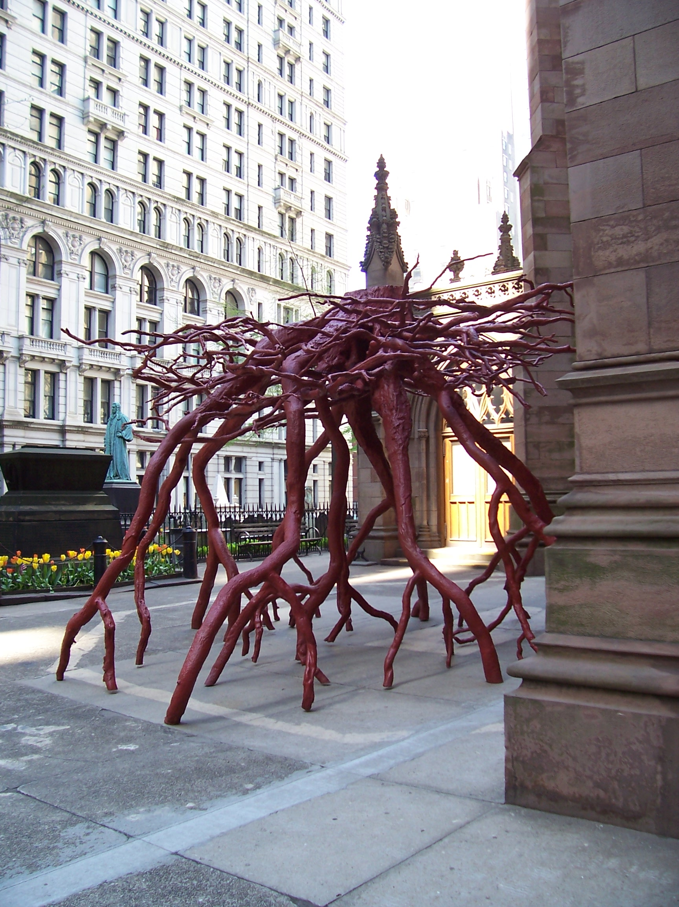
Fortunately, although New York can hardly be described as inexpensive, my ability to stay with friends in Phoenix does help, and Mexico is definitely one of a decreasing number of travel bargains around.
This bizarre sculpture in NY is a casting in iron of the roots of a large tree blown over in a churchyard by the blast from the 9/11 attacks, but which miraculously fell without damaging the church or any graves. It just impressed me as a rather eloquent, if stark, memorial to those events.
It’s many years since I was last in New York, and for the first time, I explored the ‘village’ areas more than 5th Avenue. I became especially attached to SoHo (South of Houston) which is full of independent stores and brownstones. Four days wasn’t really enough, but I was then off to Phoenix.
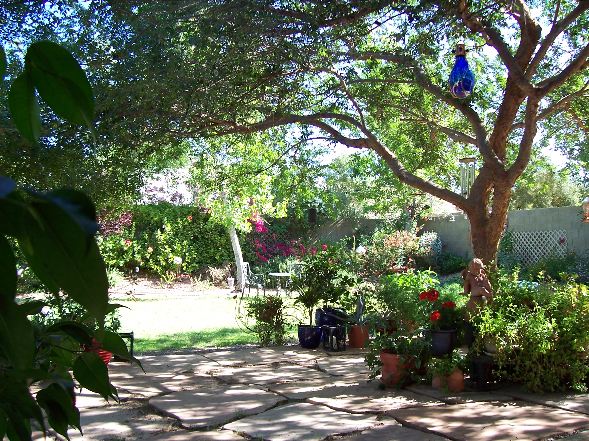
This is the rather lovely garden at my friend’s house in Phoenix. Of course I should disapprove of the water it consumes, but it is a very pleasant haven. At the time I was there, the temperatures had only crept into the 90’s by 2pm and the upper 60’s at night, so it was still quite bearable. I’m relatively unsociable but I do enjoy Nancy’s company, so we had our normal good time together and enjoyed plenty of trips out and about to my old haunts. I do still love Phoenix and the surrounding desert…
But I also love Latin America, in all it’s guises. The people have such life and seem to enjoy simple pleasures more than we do now. Maybe they just can’t afford the expensive ones! I really appreciate traveling days which are full of happy coincidental events that just happen as you wander around without any real schedule or aim.
My first day in Mexico was in Oaxaca which is pretty much dead centre in the country. Things that struck me:
The Mass at 9:30 with more than 100 people in a large church (it was Wednesday) and the young guys who looked like in NYC they’d be gang members, obediently taking Mass and following their parents. The power of the family and the church is still strong...
The ice-cream vendors setting up outside with all the shaved ice.
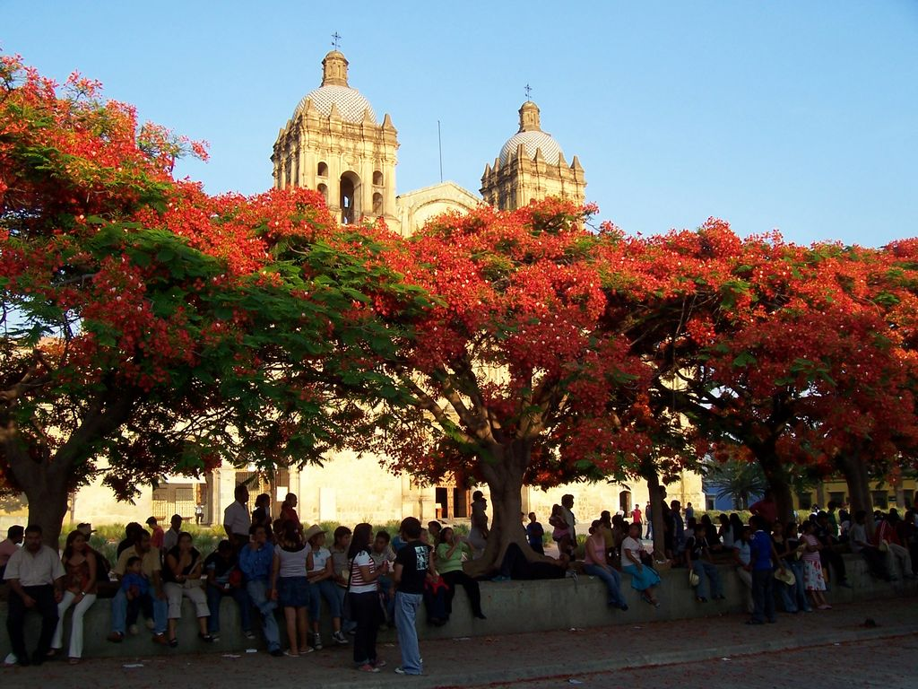
The church of Santo Domingo with so much gold on the altar, it is overpowering. And the constant stream of worshippers.
The markets - always a great experience. Hundreds of types of chilies. The flowers everywhere. The tiny lady balancing a tray with dulces on her head crying `arroz con leche` and ‘flan’ - approximately rice pudding or creme caramel.
Dinner of Mole Negro - chicken with rice in a dark, dark brown sauce which contains at least chilies, bananas, chocolate, cinnamon, garlic, and a ton of other stuff. With wine and bottled water just US$11 including tip.
And finally moonrise over the cathedral as the faithful turned out from evening mass.
Much to the dismay of my American friends (and even some Australian ones), I elected to take buses around Mexico. To my amazement, they were not the chickens in the luggage racks experience I had expected. You book online, get reserved deeply reclining seating, individual TV screens, and coffee machines. Rather more civilized than flying.
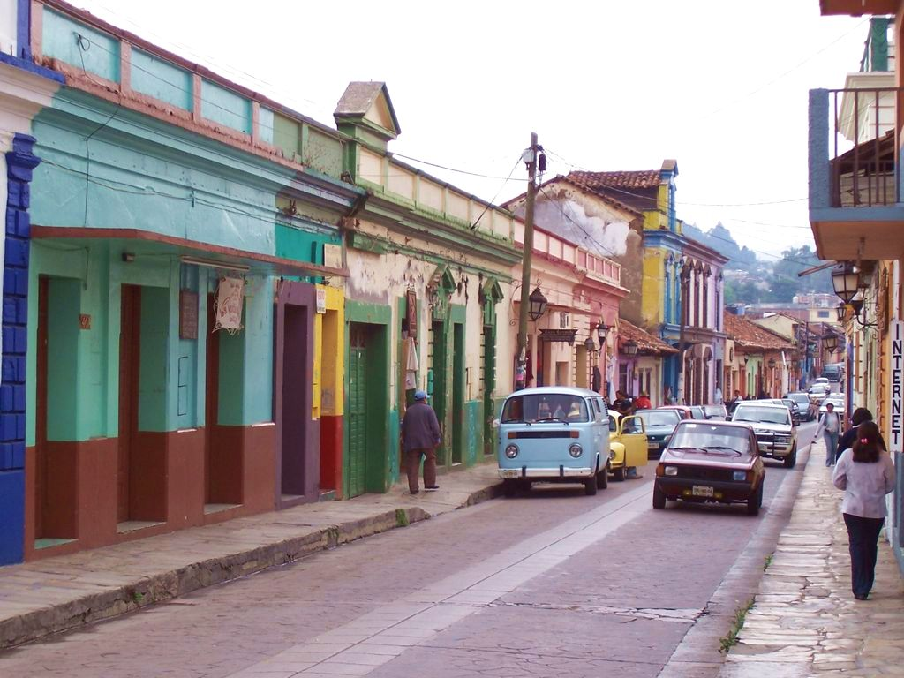
And so on I went to San Cristobal de las Casas in Chiapas, which you may recall, is the centre of the Zapatista revolution some years back, led by a rather Guevara figure - Sub-Commandante Marcos, who sported a wool balaclava with a pipe sticking out – a studious revolutionary!
This is where I had the oddest of travel experiences and learned how Coca Cola can save your soul. I arrived really early and of course the hotel I’d picked didn’t have a room ready at the time, so I went off wandering and found Alex and Raul who take tours to the nearby indian villages. Signed up and off we went in a group of about 8 (French Canadians, Dutch, Americans, and me). Heavy warnings about not taking photos of the locals as the villages are only nominally Mexican. They have their own police and their own rules. The jail is in open view. The max sentence is a week and then you have to serve your sentence as a policeman!! The duties include cleaning the public toilets and serving the village chiefs.
Before the Spanish, they worshipped Mayan gods. Then came Catholicism, and so they adopted the saints as new gods. So while they are catholic, the priest visits only once a month. The church is absolutely the weirdest ever. You go in and there are no pews. The floor is covered in pine needles. The old catholic saints statues are in big glass cases up and down each side (about 30 in all) - all with mirrors hanging on their chests (the Mayans hung reflective obsidian on their gods). And John the Baptist has pride of place as he was older than Jesus and so is clearly the senior god. And there are candles burning everywhere. Big ones in glasses, smaller multicoloured tapers stuck to the floors; all in patterns designed to achieve the required magic. And then there are the shamans doing their thing - setting up the candles, chanting, and killing the odd chicken here and there. Really basic spiritualist stuff. Totally amazing.
Oh, and the Coca Cola. Well they think that belching expels evil spirits. Last century they used beans, then beer, but in the 50’s they discovered the effects of Coke. With the added plus that the drink is nearly black - a good omen for getting the attention of evil spirits. So now there are coke bottles incorporated in the rituals on the floor. Even though they’ve seen tourists it was as if we weren´t there. Just amazing stuff.
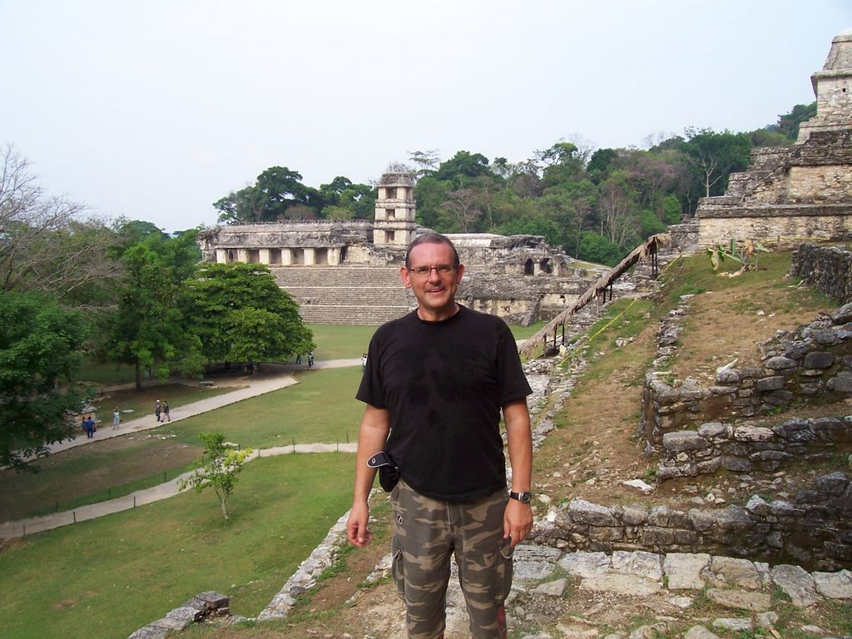
To abbreviate somewhat, I then traveled 8 hours into the Yucatan jungle to visit Palenque which is probably the most noted Mayan ruin in the world. Let me tell you, this is really jungle at about 90% humidity and similar temperature. I really enjoyed the detour but was somehow disappointed to find that my very humble hotel sported cable TV. There is nothing quite so reconnecting to the ‘civilised’ world as ‘Shakespeare in Love’ with Spanish subtitles.
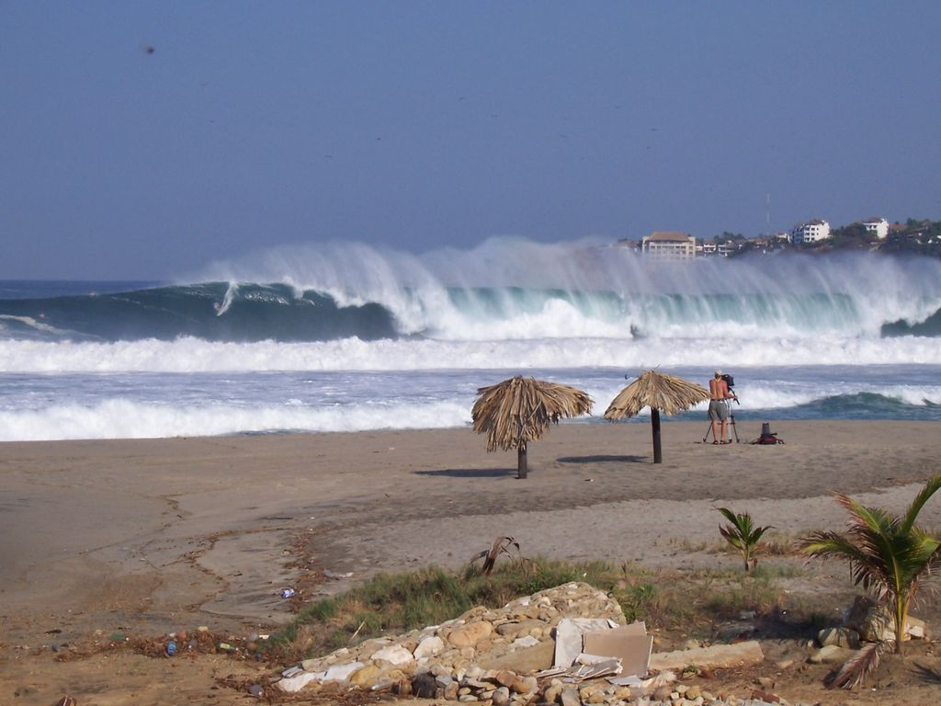
And so to Puerto Escondido which is reputedly one of the five best surfing beaches in the world. Of course I don’t surf, but an episode of gout had me limping and putting up a good impersonation of an injured surfer! Very big waves at about 24 feet (the line about a third in from the left is a surfer risking life and limb). I loved Puerto Escondido, not least for its very laid back and originally Mexican atmosphere. Fish grilled straight from the catch on the beach takes a lot of beating…
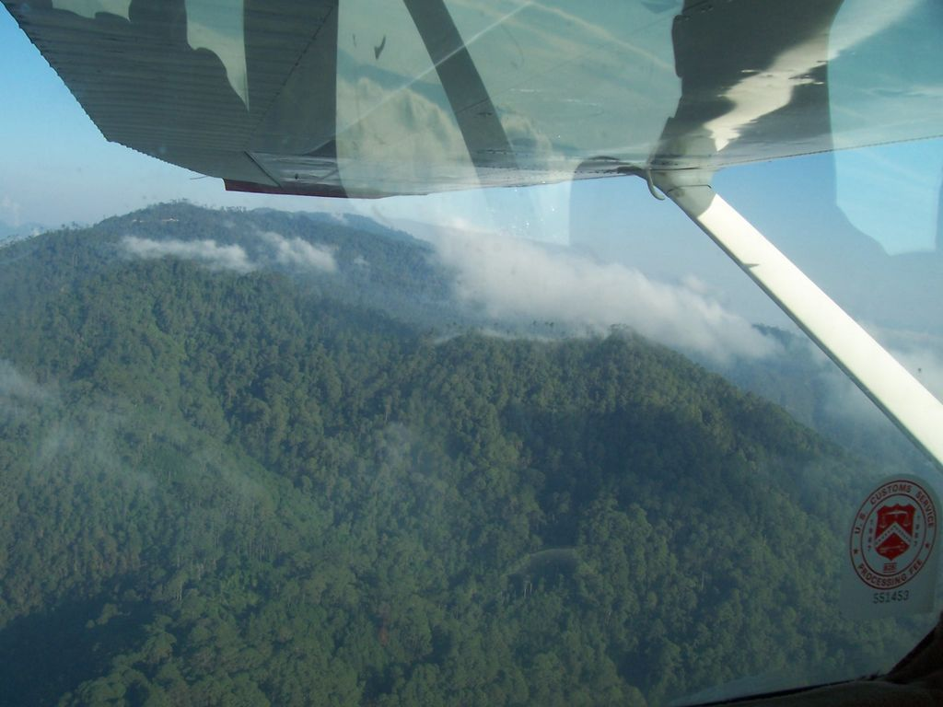
And talking of life and limb, a single-engine Cessna was my transport back to Oaxaca flying through, rather than over, 9,000 foot passes.
Unsurprisingly, I concluded in Vegas after a further brief stay in Phoenix. And so to Sydney. It was, of course, great to see friends again and to be complimented on my outstanding tan! But it’s been an extremely cold winter here and now the trip seems an age ago.

My good friend Nikki is off to South America for six weeks in September and I’ve been heard to mutter darkly about wanting to go away again, which gets very little sympathy as she has not had a vacation for two years.
I will be minding her rather cute Pomeranian and two cats while she is away. It’s a good thing that my apartment committee (abnormally) permits pets in the building.
I do believe, though, that travel will continue to be a regular feature of my life. Especially as I discovered when I was away this time that there are internet cafes with very speedy connections on almost every corner at extremely low prices and that I can quite easily conduct my business from them.
I do hope this has not been too much of a travelogue, but I think that is rather more interesting than my day to day existence. If the timing is right, you may expect another one when my turn comes up again!
Hoping that you continue in fine form,
l

