11847 E Appaloosa Place
Scottsdale AZ 85259
USA

Thursday, 12th March, 2003
Dorothy Pearce
240 Martin Way

Morden Surrey SM4 4AW
England

Dear Dorothy,

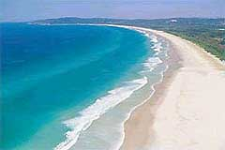
Hello from beautiful Tallow Beach at Byron Bay, NSW, Australia. Is it any wonder this letter is late… (All due apologies, however)
As you can see, I am ‘doing a Frank’ with some photos, but my page setting talents are zero, so you will have to settle for a letter with pics rather than an Aussie Clarion. Rupert Murdoch I’m not!
Anyway, I am taking my normal (northern) winter break in Australia. This despite the fact that the downturn in the US economy is hurting my business and up to the last moment, I had nobody to rent my house. My realtor tells me that rentals are the worst she has ever seen with everyone either postponing plans or going for the cheapest option which at present is one of the plethora of ‘all suite hotels’, offering killer rates for a room with separate bedroom and very limited cooking facilities. They do not come close to my home in facilities, but are perhaps half the price. Fortunately a couple has turned up at the last minute and taken my home for February and March – albeit at something of a ‘knockdown rate’.
My time in Australia is proving a very mixed bag. I spent the first two months in a very pleasant apartment in Sydney. All the normal luxuries were available (gym; pool; spa), but I was (and am) very busy trying all options to improve my business. One of these involved a complete redesign of our old website to make it appear more professional and hopefully dispel customer fears that they might be about to commit credit card details to a bunch of crooks. The look is intentionally rather unashamedly American. At the same time, we are working on a totally new site to run in parallel with the old one. This is to be totally international (www.world-retail-store.com) and we will probably launch in early April. The aim is to get a broader presence in the search engines which are the main source of information on the internet. As listing with these engines is free, they have had a rather major problem in figuring how to make money. While the internet was the financial flavor of the month, profits didn’t matter. But now they do, and very few search engines remain in business. To give you an idea of the stupidity of it all, one of the very first engines (called Altavista, and started by Digital Equipment back in the early 90’s) was just sold for $200million. Its previous owner bought it with shares, but only about 3 years ago paid the princely sum of $2.6 billion. I wouldn’t be very happy in their shoes.
So my problem is to try to get as broad a presence as possible in the few remaining locations. It’s a little as if we were a concert promoter relying on flyposting as many walls and lampposts as possible, but where the walls are being knocked down all the time. Interesting but a little worrying at times…
I was originally intending to take a trip to Europe by way of a lazy return from Sydney to the USA, but I became too busy and have elected to stay in Australia until the end of March when my house becomes available. Not one to work too hard, or at least in order to placate my friends who were getting fed up with my complaints about all work and no play, at the end of my initial lease period in Sydney, I decided to decamp north. Everybody told me that Byron (the most easterly point in Australia and about 750km north of Sydney) is a reasonably cosmopolitan location for seaside NSW. Basically this is true. It is a small town but it has an interesting combination of luxury (with some hotels at over A$700 a night) but also a great 60’s type hippy influence from the many backpackers who come for the surf and the totally laid-back lifestyle. The latter is currently giving rise to a huge crop of ‘NoWar’ banners and painted signs on homes and offices. In that context, it occurs to me that, if I go for US citizenship in August, I will have a hat-trick of citizenships in the ‘coalition of the willing’ - assuming of course that the first ‘regime change’ isn’t in London!
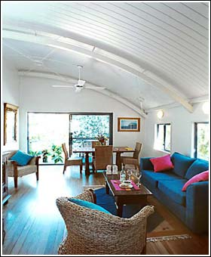
The place I now have in Byron is a great little apartment, the major benefit of which is that it is a mere 100feet or so from the beach you see at the top of this letter. Colorfully decorated with Balinese influences, it still has the kind of technology I love – namely a satellite TV connection and surround sound.
The beach outside the door is about 3 miles long and I have never been able to count more than 20 people on the entire length.
But it does seem that Byron has been forgotten by the telecoms companies, as you see people taking very strange steps to try to get any kind of signal from their mobile phones.
As I write, the sun is just coming out again after a tropical downpour – much welcomed here as the statewide drought has seen Byron’s water storage drop to 25% of the norm at this time of year.
I just saw a good attachment on my drive home from town. It’s a sort of sidecar for a bicycle to allow the transportation of a full sized surfboard. Very Australian…
Let me step back in time…
Just before Christmas, despite my love of the sun, I felt the need for some Christmassy scenes and a little variety.
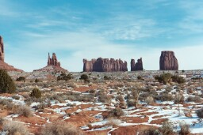
I am sure you will all recognize this as Monument Valley, but might be surprised by the snow. I was too, but you have to remember this is about 7000 feet above sea level and it gets mighty cold in the winter months.
On my trip north, I missed the Grand Canyon and went straight on to Monument Valley, past Mexican Hat (a town named for the sombrero-shaped formation on its outskirts), to Blanding in Utah.
But the drive did get a little alarming at one point. I was on a perfectly normal regional road which suddenly turned into a dirt track with dire notices about ‘switchbacks’ for 3 miles. I was facing a huge escarpment and could see no way for the road to skirt it. That’s because it didn’t. After a very un-American stretch of highway (actually track would be more appropriate), I arrived at the top…
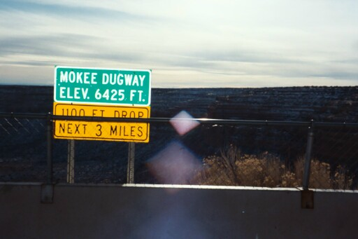
I can assure everyone that, if not a one-horse town, Blanding is a two-street town, those being Central and Main which meet at the only stop sign (no lights). There is one restaurant which closes at 7pm as I discovered on locating it at 7:10! But on local television you get the Mormon Tabernacle Choir doing carols, which was some compensation for the absence of any other redeeming features. I should have progressed another 40 miles north to Bluff which is the gateway to Arches National Park.
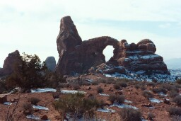
I have never been to Arches before, but it is now one of my favourite parks. It is full of, well, arches. But giant ones like this where the keyhole is about 40 foot high and similarly wide. It is quite an experience to trek up to and under one.
To add to the experience a friendly coyote came to say hello while I was standing in awe.
After Bluff, I continued a little north of Bryce Canyon and overnighted there. The next day brought a severe snowstorm and it is only down to the LandRover that I made it out and down to the valley and Las Vegas some 300 miles beyond. It does get rather alarming when a 4 wheel drive vehicle starts moving sideways as well as forwards…
Well, making a major shift from snow to sun, I am contemplating the long drive back to Sydney on Sunday and then my return to the USA at the end of March. I suspect that after next August, if I have my US citizenship, I shall have to make a decision on a real permanent home. All this travel is too much for a semi-centenarian.
Talking of which I hope everyone, and of course especially Dorothy, had a great time at the great event in Feb. I am sorry I couldn’t be there and cannot therefore be the first to relay a report on events.
l

