You know your services are targeted at a very high-end clientele. Your website reflects that aim.

Close to 100% of those clients will be totally attached to their Blackberry/iPhone/Palm/G1.
They will use it to get quick answers off the internet. It’s personal, private, and with them 24/7.
But when your potential client views your normal website, it will not be nearly as impressive on a mobile phone – if it works at all…

For a very limited period, we will build you a mobile website, with no upfront cost and with no obligation for you to take the result if you do not want to.
If you do like the result, can see the benefits, and want the website to become yours, there is a once-only payment of $200 (less than a month’s advertising in a major directory).

Your payment buys:
- Ownership of the design
- Registration of a .mobi top level domain name for one year
- Hosting of your site for one year
- Preferred position in our mobile escort directory (launching in June).

Please have a look below at how your website now looks on a Blackberry and an iPhone – and how we have made a new look for one of our clients.

If, you want to go ahead (without any obligation whatsoever), just email back to us with a ‘YES’ and we will take the content off your normal website – so you have absolutely nothing more to do. Then we’ll let you know when we have something for you to look at…

Thank you,

Simon
gfe2go.com

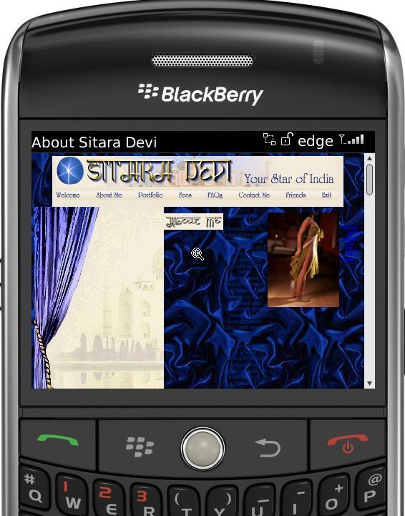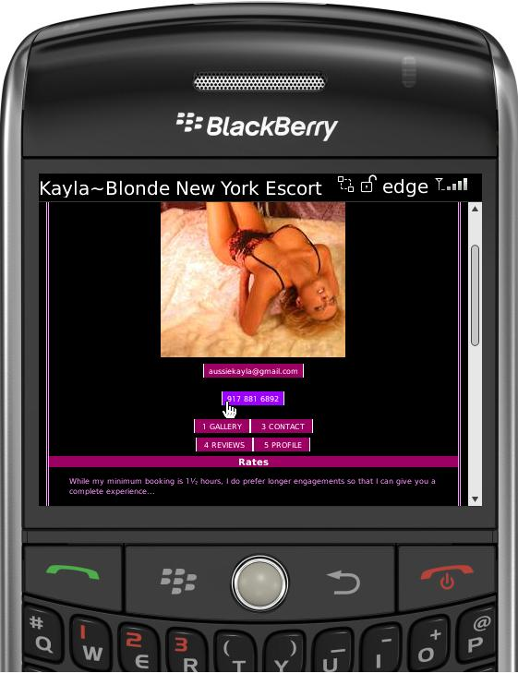
Example: © AussieKayla.mobi
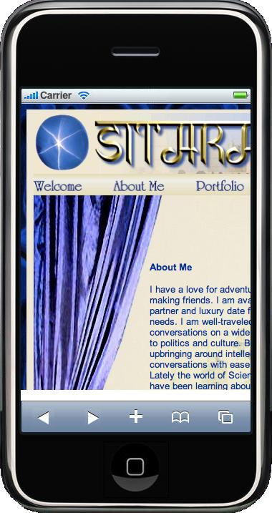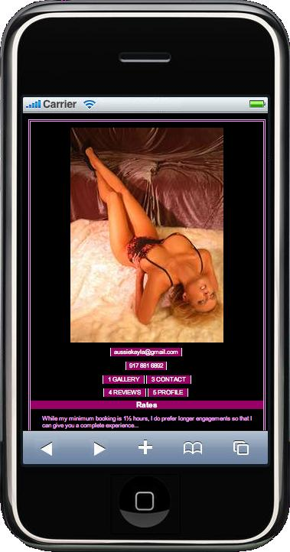
Example: © AussieKayla.mobi

