
RISK ASSESSMENT & MOBILE EFFICIENCY RESULTS
FOR

www.sofiamiles.com

Domain registered with: | SquareSpace
Privatized/where: | Yes/USA
Registered with real name? | Unknown
Hosting/where: | SquareSpace/USA
Platform: | SquareSpace (other options would be wix, wordpress, html, etc)

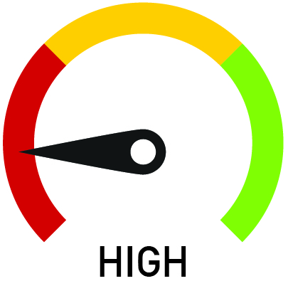 | DOMAIN REGISTRATION  Factors that affect risk with respect to domain registration and your personal information remaining private include:  - Who your domain is registered with – being registered with a US registrar increases your risk  - Location of any domain privatization service – same as above  - Did you use your real name when you first registered the domain  - Was the domain has been privatized the entire duration of ownership  - Your domain registrar's restrictions or delays on change of contact information or transfer to another registrar

WEBSITE HOSTING & PLATFORM
Factors that affect risk with respect to website hosting and your website being shut down include:
- Where your hosting company is based and their ultimate ownership (companies located in the US or owned by a US corporation carry significantly higher risk)
- Does your hosting company specifically allow adult content? Could their Terms of Service allow them to close your account (eg for 'illegal activity' or 'bringing the host into disrepute')
- Was your site built on a self-design platform like Wix, SquareSpace or GoDaddy. These sites DO NOT allow the promotion of any illegal activity (as they choose to define that). Your site could be shut down without notice, refund, or recovery of content. They DO NOT allow you to transfer the website you built on their platform to another hosting service.
- Is your hosting company (and the servers they use) based in a country where your activities are legal; the USA is not the only country where laws exist to limit activities
MOBILE WEBSITE – RISK OF LOSING CLIENTS
Factors that result in you losing potential clients wanting to view your website on their mobile devices (around 60% of all your visitors based on latest statistics):
- How quickly your site loads
  - Over 3 seconds probability of losing client increases 32%
  - Over 5 seconds probability of losing client increases 90%
  - Over 6 seconds probability of losing client increases 106%
  - Over 10 seconds probability increases 123%
- Mobile speed depends on both design and where your site is hosted; some low-cost servers are very slow; self-design service sites are significantly slower than bespoke designs due to their 'one size fits all' coding bloat.
- Mobile friendliness of site – if it isn’t easy to use, people will not stay on the site; most mobile sites are created as an afterthought to laptop design; in reality mobile is where the majority of your clients browse and where a great user experience (UX) is hardest to achieve
- Images and video are the most engaging mobile design features; on badly designed sites they frequently require screen rotation to view, are randomly cropped in vertical screen mode, and are not optimized for loading speed
- Google recently announced a significant change in how it ranks websites for mobile searches: it will now take page speed into consideration as one of its signals, the company says. The change, which Google is referring to as the “Speed Update,” will go into effect in July 2018

YOUR MOBILE WEBSITE TEST RESULTS
