URGENT - UPDATE YOUR DIRECTORY LISTING

You have been included in our free escort directory designed for mobile phones.
- Please correct your information and email back to us.
- Confirmed listings will show first on the directory.
- For top listing, email attach or upload a recent photo for the directory.
- The directory will launch with comprehensive listings in June 2009.
Correct and confirm:
Email: sexybbwcarla@gmail.com
Name: Sexy BBW Carla
Country: USA
City: Las Vegas
Tel: 702-565-6556
Website:
Languages spoken:
Hourly fee (please indicate currency – eg USD; GBP; AUD):
Keywords: (eg GFE; PSE; B&D; TS; Mature; etc):

[The more relevant keywords you can provide, the more we will match searches to your specialty]

Just attach your photo to this email when you reply and it will appear on our directory.
Alternatively, you or your friends can enter a new listing and upload your photo at data.gfe2go.com.

If you do not wish to be included in the directory, please type ‘remove’ at the top of this email and return to us.

Thank you,
webmaster@gfe2go.com

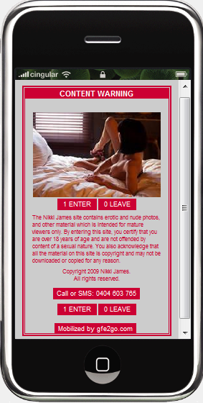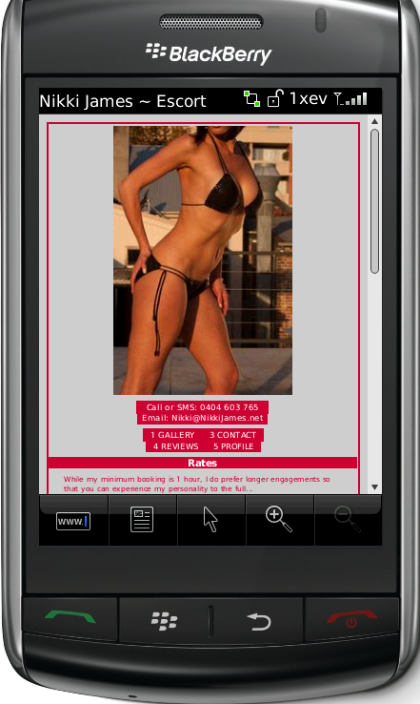
Example: © NikkiJames.mobi

- Sexy BBW Carla
sexybbwcarla@gmail.com

