URGENT - UPDATE YOUR DIRECTORY LISTING

You have been included in our free escort directory designed for mobile phones.
- Please correct your information and email back to us.
- Confirmed listings will show first on the directory.
- For top listing, email attach or upload a recent photo for the directory.
- The directory will launch with comprehensive listings in June 2009.
Correct and confirm:
Email: lea@peggandgrant.co.uk
Name: Lea Very busty English lady
Country: UK
City: Croydon
Tel: 07534 099227
Website: leaescort.weebly.com
You or your friends can enter a new listing and upload your photo at data.gfe2go.com.

If you do not wish to be included in the directory, please type ‘remove’ at the top of this email and return to us.

Thank you,

webmaster@gfe2go.com

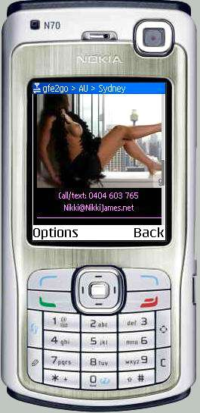
Example: © NikkiJames.mobi

- Lea Very busty English lady
lea@peggandgrant.co.uk

