OPEN
media pty limited
Box 613, Brighton Le Sands
NSW 2216, Australia
Tel 02 8006 4948
E-mail simv@pobox.com

31 July 2026
Invoice # OM101001

3e Consulting
272 1ST Ave Apt 10E
NEW YORK, NY 10009-1804

SERVICE PERIOD TOTAL VALUE US$
Website management and maintenance Nov 2010 US$200
Payable 7 days
JP Morgan Chase – Account # 788 869 618 (Simon Verdon) – Routing Code # 122100024
PAID IN FULL BY OFFSET AGAINST AMOUNTS OWING – REMAINING BALANCE $200
Signature....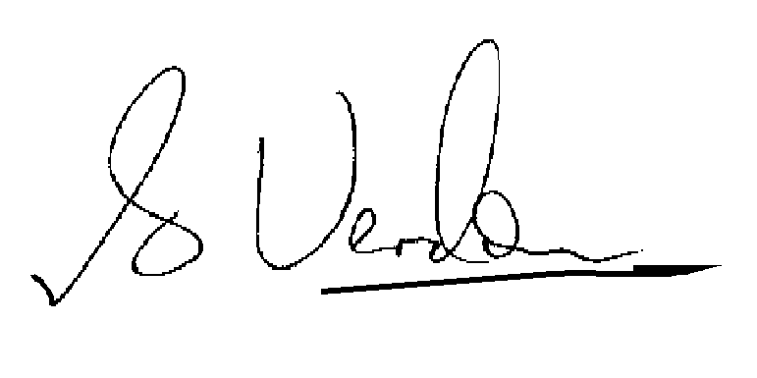
S.I.M. Verdon, Director, Open Media Pty Limited

