OPEN
media pty limited
Box 613, Brighton Le Sands
NSW 2216, Australia
Tel 02 8006 4948
E-mail simv@pobox.com

30 July 2026
Invoice # OM100701

3e Consulting
272 1ST Ave Apt 10E
NEW YORK, NY 10009-1804

SERVICE PERIOD TOTAL VALUE US$
Website management and maintenance July 2010 US$200.00
Renewal of Karyna.us for 1 year US$19.99
Payable 14 days
JP Morgan Chase – Account # 788 869 618 (Simon Verdon) – Routing Code # 122100024
Signature....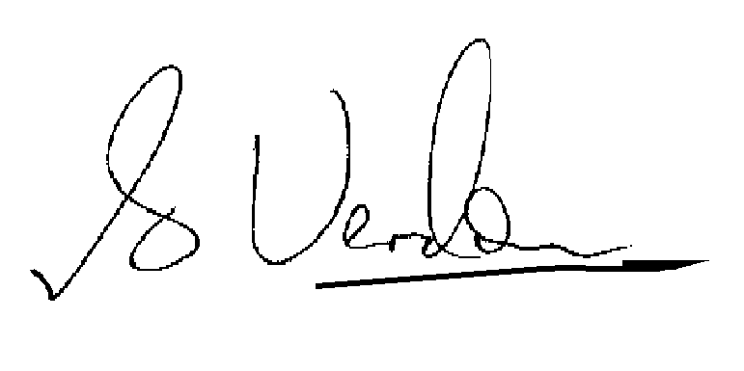
S.I.M. Verdon, Director, Open Media Pty Limited

