Vivienne Cole

<https://www.viviennecole.com/>

I grew up in sunny San Diego, and am asked constantly why I would ever want to leave, but as it turns out -  sunshine is only the tip of the what-I-want-out-of-life iceberg. I want variety. I want smart, dynamic friends (& lovers), cinemas that show the limited release films that never came to San Diego, restaurants with voluminous wine lists, and stamps of approval from Pete Wells, legendary galleries & museums, an International airport launching over 800 flights per day...the list goes on (I guess I'm greedy). But here in the Big Apple, I've found all that and more. Only the boring get bored in New York.

I feel super lucky to lead the life I do. A spunky lady once said "We only live once, but if you do it right, that's enough."

I have a passport peppered with stamps and visas, a few languages up my sleeve, and a never-ending tick list of places to see.

Brooke Lordes

<http://www.brookelordes.com/>

<https://www.slixa.com/new-york/new-york/brooke-lordes>

I have a wide variety of interests and am always eager to learn about new things. I hold a degree from a major American university, and I am a voracious reader. I am especially drawn to literature, poetry, continental philosophy, critical theory, and psychology.

I’m a film-buff and fanatic for fine art, fashion, and music. Traveling is a passion. As a party-trick, I read tarot and astrological charts: my once-teenaged pastime never fails to entertain even the most embittered skeptics (a type I always love).

I’m a published writer and I am often on deadline. While I am driven in my writing career and literary aspirations, I remain an unpretentious kitten. I like to be light-hearted and have fun. Above all, I enjoy life.

Marla Lyons

<https://marlalyons.com/>

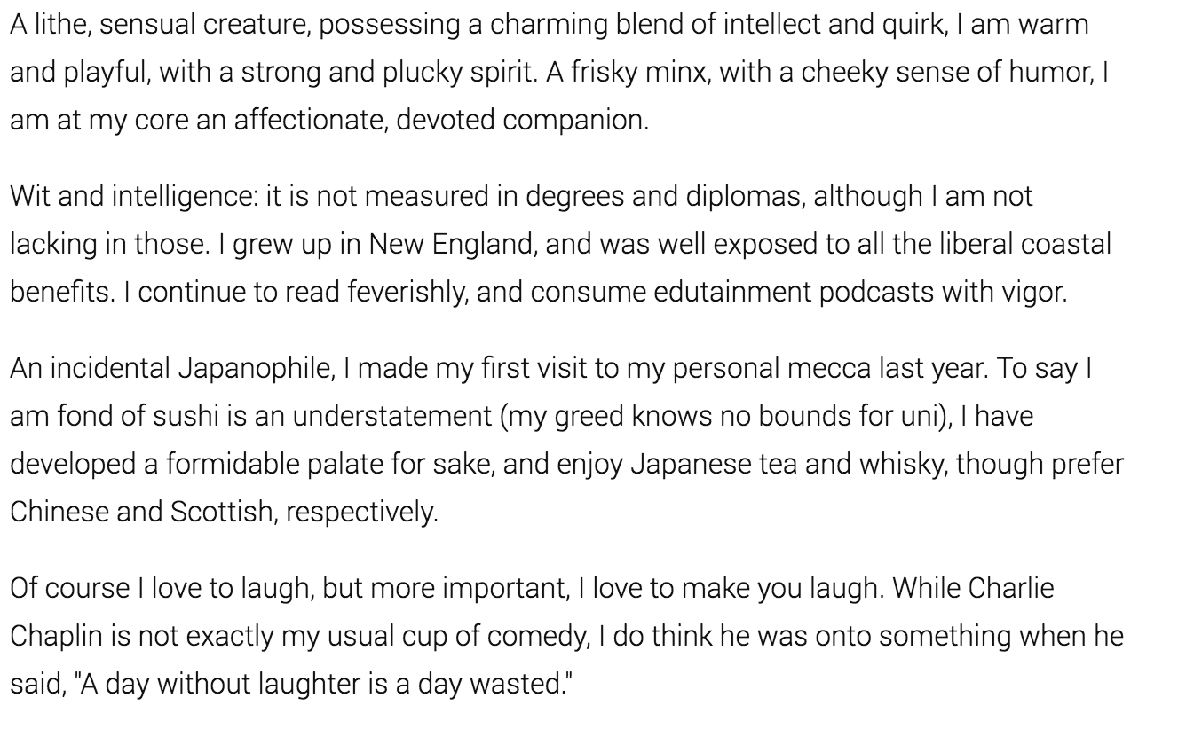

Brooke Nichols

<https://thebrookenichols.bz/>

There’s a reason I’m known as a muse. I’m interested in what’s genuine- authentic connections, inspired conversations, and unforgettable experiences. Growing up in a bohemian city along the coast encouraged my champagne-bubble-about-town personality- you’ll find my sparkling eyes and cheeky smile inspires your excitement.

As much as I enjoy opulence and luxury- and I do!-  what I cherish most is thoughtfulness and compassion. Fitness of mind and body are of equal priority- I stay toned and tan with a balance of Pilates and beach frolicking. When not adventuring in remote lands, you can find me visiting independent book stores, museums and enjoying New York’s culinary delights.

Sofia Miles (Simon has)

<https://sofiamiles.stickysites.ch/>

I tried the whole doe-eyed, naive little xkitten-thing. The I am whoever you want me to be, I think whatever you want me to think kind of thing. I am not good at it. Not good at all. In fact, I am rather intelligent, a little opinionated and as you can see, quite confident too.

But I am not a pretentious know-it-all. I love being introduced to new thoughts and ideas and I find people’s passions, beliefs and opinions incredibly exciting. I have a very curious, flexible and open mind and a very loving, life-embracing personality that I am eager to share with the people around me.

I feel equally at home at a fine dining venue, members club or first class cabin, as I do drinking cheap beer at a dive bar, camping in the wild or singing karaoke with strangers. I believe one end of the spectrum is only as exciting as it’s opposite. Life is too short to only live one!

My love for life and authentic experiences extends to the sensual. Physical expression is a huge part of my personality and I believe the body is as important as the mind. If not more. I’d like to find out what makes you tick and tingle, feel you, sense who you are or who you would like to be and go there with you. And I’d like to show you who I am, what I like and what gives me pleasure.

Bryleigh

<https://fantasies2night.com/>

I am inquisitive. I am genuine; a woman of many talents, convictions, and aspirations. Undoubtedly influenced by my past and present choices, both advantageous and detrimental, a path formed. Along that path resides the people who have helped me create the wonderful outline of the woman I wish to be, and for that, they are held in the highest point of my heart.

One of the things that has most shaped me is my classical ballet training. Ballet has such an enigmatic duality to its nature. A dance performance is filled with grace, delicacy and femininity. Dancers embody perfection of the female form, not only with the way they look, but their exquisite precision of movement and their harmony with the music. But behind the almost ethereal stage presence is an incredible strength that comes from rigorous training of both body and mind. Ballet has taught me that through perseverance and focus, I can create timeless beauty.

I am a deeply sensual person and I love nothing more than spending time with someone who can appreciate the myriad ways that our senses can be stimulated. Take me somewhere we’ve never been before, so that we can marvel together at the newness, or take me to a favorite haunt so that I can see it fresh through your eyes. I love meeting new people. Will this be you?

Evelyn Greene

<https://www.experienceevelyngreene.com/>

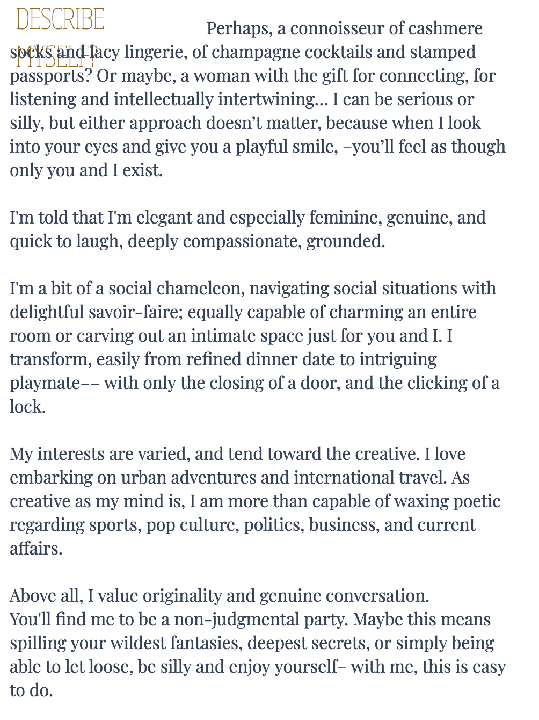

Isabelle Ducharme

<https://isabellevip.ch/>

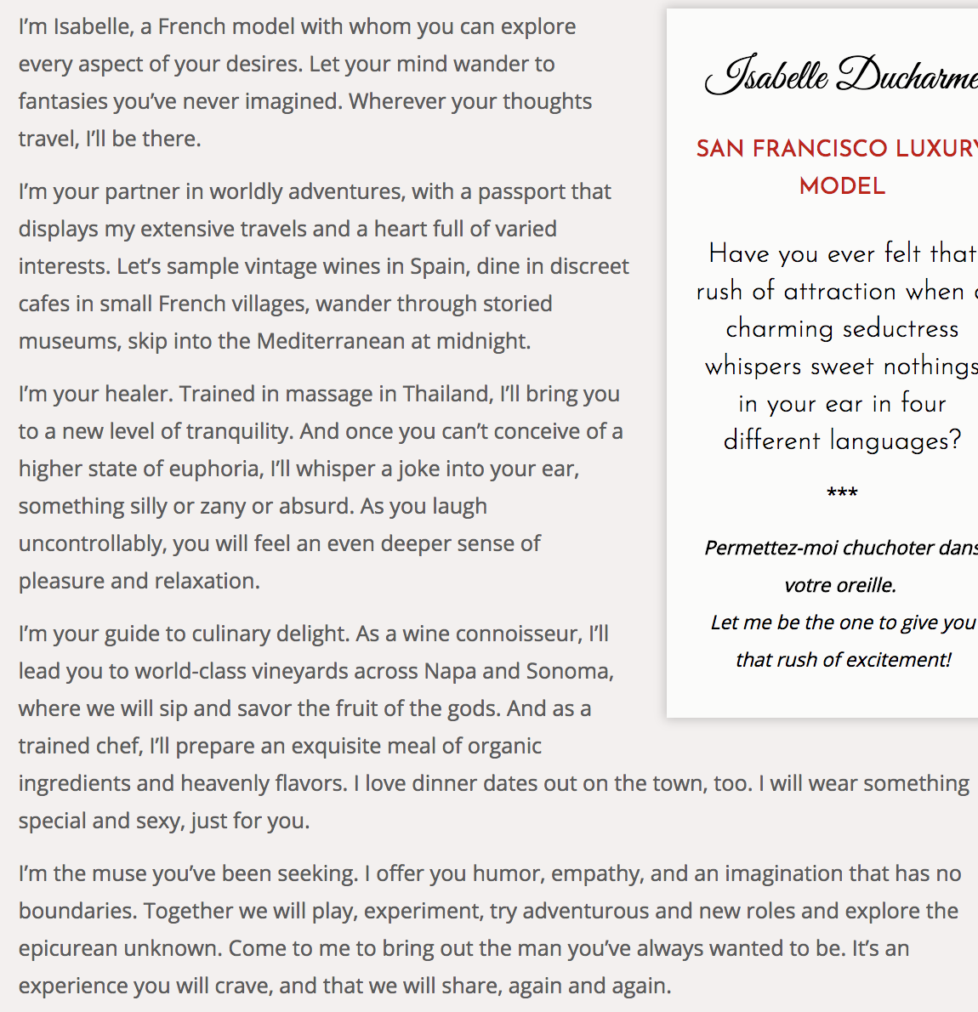

Laynie

<https://layniejames.com/>

…. Your fabulous text …

Lydia Cameron

<https://www.meetlydiacameron.com/>

In 1827 General Clausewitz wrote, ‘War is an act of human intercourse.  It is no pastime; it is no mere joy in daring and winning, no place for irresponsible enthusiasts.’

Timelessly, like war, sharing true intimacy is consequential---stirring emotions and primal senses.

Who will be the first to disarm?

First we face each other.  My armour is a slinky, elegant dress that teases my curves.  My infantry are soft kisses that maneuver towards the previously inaccessible. My intuitive sense of your body is the ambush to draw you out. My never-ending caresses the cavalry charge.

I wonder which of us will deploy our missiles first? I never bluff.

If I feel you retreating into yourself, my sweet attention will coax your return to the front lines.

Finally, when the last of your defenses lay strewn, I’ll invite you into my embrace to join forces and move as one.

Unlike the battlefield, with intimacy there is strength in surrender. From relinquishment we can forge something profoundly sublime: an authentic human connection.  I have no interest in subterfuge or personas; I value each experience as a singular, mutual exploration of intimate delights and chemistry of heart, body and mind.  The greatest compliment you can give me is to be yourself.  To impress me; just be.

​

Whisper the fantasies that thrill and frighten you. If you’re excited, let me share your joy.  If you’re feeling cynical, let me gently sooth you out of your pessimism.  The world does not always reward earnestness and it is too easy to be contemptuous of those who wear their hearts on their sleeves. But in me you will find a partner who admires your strengths, cherishes your secrets and respects your vulnerabilities.

I have had the great fortune of experiencing different cultures and have lived all around the world.  Now here we are. I’m awed imagining the miles and oceans you and I have traveled to encounter each other. Now our journey crosses paths. However we proceed, let it be with romance; affectionate, passionate, sweaty, unabashedly, remorselessly real.

Slaughter the horses.  Burn the bridges.  Come cross the Rubicon with me and be thrilled as we lose ourselves completely.